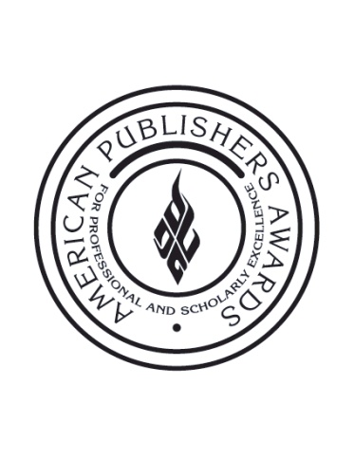

FOR IMMEDIATE RELEASE Contact:
Jessica Weeg
646-695-7043
jessica@rosengrouppr.com

PROSE Awards Premieres Fifth Annual Short Film, The Curators

New York, NY, January 29, 2013 – The Professional and Scholarly Publishing Division of the Association of American Publishers will debut its fifth annual short film during this year’s American Publishers Awards for Professional and Scholarly Excellence (PROSE) ceremony. The Curators, a five minute short film depicting the crucial need for editors in the competitive field of publishing, will premiere at the ceremony held Thursday, February 7 at the Ritz-Carlton Hotel in Washington, DC and by live webcast.

“Editors bring invaluable expertise during this transition from print to digital media,” said PROSE Awards Chairman John A. Jenkins, president and publisher emeritus of CQ Press. “As digital platforms become more popular, it’s increasingly necessary to have a savvy editor perfect the subtle cues that make a book successful on every platform, whether it’s read in print, on a tablet or on a smart phone.”

Directed and produced by award-winning New York filmmaker Mary Rose Synek, the film follows three works from three publishers – Cambridge University Press, American Institute of Physics, and McGraw-Hill Professional – through the publication process.

“Filming the The Curators was an eye-opener—we were able to see how each work has been processed, checked and rechecked to be as close to perfection a possible,” said Synek. “Exploring the expertise behind the scenes left us humbled; the editor is indeed irreplaceable in this process.”

For the 2012 award season, the PROSE Awards received a record high of 518 entries from 70 publishers across the United States and abroad. The judging panel, comprised of 14 academic and industry experts from across the globe, convened in New York City in early January to decide the winners in each category, including the prestigious R.R. Hawkins Award recognizing the most outstanding professional and scholarly work of 2012.

All honors will be awarded during the ceremony in February; followers can track the winning entries as they are announced by following the #PROSEawards hashtag and @PROSEawards handle on Twitter.

About AAP
The Association of American Publishers is the national trade association of the U.S. book publishing industry. AAP’s more than 300 members include most of the major commercial publishers in the United States, as well as smaller and non-profit publishers, university presses and scholarly societies. AAP members publish hardcover and paperback books in every field, educational materials for the elementary, secondary, postsecondary, and professional markets, scholarly journals, computer software, and electronic products and services. The protection of intellectual property rights in all media, the defense of the freedom to read and the freedom to publish at home and abroad, and the promotion of reading and literacy are among the Association’s highest priorities. For more information on the PROSE Awards, please visit: www.proseawards.com. Follow award updates on Facebook and Twitter.

# # #

