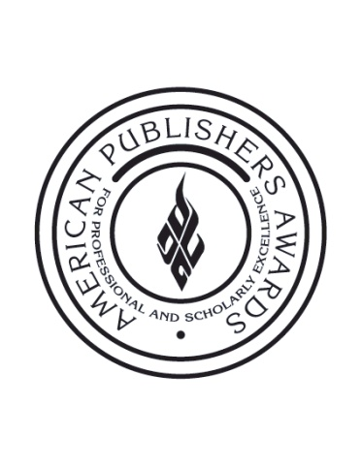

FOR IMMEDIATE RELEASE Contact: Kristin Nerup Vincenzo
646-695-7043
Kristin@rosengrouppr.com

Searching for the Next Star in Scholarly Publishing:
Association of American Publishers Announces 37th Annual
PROSE Awards Call for Entries

Washington, DC, July 24, 2012 – The Professional and Scholarly Publishing (PSP) Division of the Association of American Publishers (AAP) today announced the call for entries for this year’s American Publishers Awards for Professional and Scholarly Excellence (PROSE) Awards. Now in their 37th year, the awards recognize books, journals and electronic products that contribute to professional and scholarly publishing, while also maintaining the highest editorial and design standards.

“This year’s PROSE Awards should be the most exciting yet,” said PROSE Awards Chairman John A. Jenkins of CQ Press. “By expanding the award categories, we anticipate an increase in submissions—and competition—for what has become the industry’s most prestigious recognition of scholarly publishing achievement.”

Book submission categories for this year’s PROSE Awards include: humanities, reference works, mathematics, social sciences, physical science, as well as biological and life sciences. E-products and electronic platforms with multiple components, meanwhile, can compete for best in humanities, best in multi-discipline platform, best in physical sciences and mathematics, best in biological and life sciences, and best in social sciences. Journals may be entered in print or electronic formats.

Five “best of” awards will be chosen from the winners of the books, e-products and journal categories. Only one PROSE prize winner, however, will take home the prestigious R.R. Hawkins Award, which recognizes scholarly works in all disciplines of the humanities and sciences.

“Winning the R.R. Hawkins Award was a tremendous honor for McGraw-Hill because it underscores the value of engineering and the sciences—the importance these technical fields and their applications contribute to our everyday lives,” said Michael Penn, Senior Editor, McGraw-Hill Professional, publisher of The Diffusion Handbook: Applied Solutions for Engineers and winner of the 2011 R.R. Hawkins Award. “After winning the award, we saw a significant boost in sales in wholesale, library, and special sales channels—the PROSE Awards helped to elevate visibility of the science and engineering category within the world of scholarly publishing.”
Books, journals and e-products submitted for this year’s PROSE Awards must be published by a member company of PSP, AAP, or the Association of American University Presses (AAUP). All book entries are required to have a 2012 copyright date, and new journal entries must be published a minimum of two times after 2010. E-product entries must have been launched or changed significantly in 2012. Winners will be announced at the PROSE Awards Luncheon at the PSP Annual Conference in Washington, D.C. on February 7, 2013 and be broadcast via live webcast.

For additional 2012 PROSE Awards entry details including rules for eligibility, guidelines and required submission information, visit www.proseawards.com.

About AAP
The Association of American Publishers is the national trade association of the U.S. book publishing industry. AAP’s more than 300 members include most of the major commercial publishers in the United States, as well as smaller and non-profit publishers, university presses and scholarly societies. AAP members publish hardcover and paperback books in every field, educational materials for the elementary, secondary, postsecondary, and professional markets, scholarly journals, computer software, and electronic products and services. The protection of intellectual property rights in all media, the defense of the freedom to read and the freedom to publish at home and abroad, and the promotion of reading and literacy are among the Association’s highest priorities.

# # #

