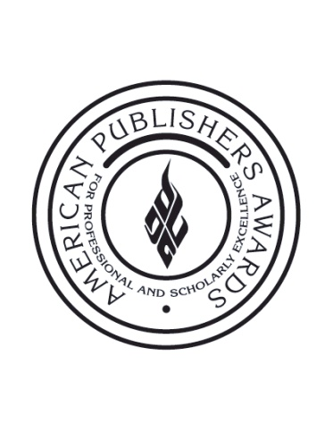

FOR IMMEDIATE RELEASE Contact:
Jessica Weeg
646-695-7043
jessica@rosengrouppr.com

37th Annual PROSE Awards Tallies Record Number of Entries,
Brings Twitter into the Judging Room and Awards Ceremony

NEW YORK, NY (January 7, 2013) – Shining a bright spot on publishing, the Professional and Scholarly Publishing Division of the Association of American Publishers is proud to announce a record number of entries for this year’s American Publishers Awards for Professional and Scholarly Excellence (PROSE). Now in its 37th year, the awards for the first time will incorporate live tweeting during the judging process, allowing followers a sneak peek into the judging by following the #PROSEAwards hashtag and @PROSEAwards handle on Twitter.

The awards ceremony on Thursday, February 7 at the Ritz-Carlton Hotel in Washington, and the concurrent global live webcast, will also feature a real-time feed of tweets using the #PROSEAwards hashtag. Whether in the room or not, followers of @PROSEAwards will know the winning entries as they’re announced.

For the 2012 award season, the PROSE Awards received 518 entries from a total of 70 publishers across the United States and abroad. The judging panel, comprised of 14 academic and industry experts from across the globe, will convene in New York City on January 7-8, 2013 to choose the winners, including the prestigious R.R. Hawkins Award recognizing the most outstanding professional and scholarly work of 2012.

“The record number of entries speaks to the enduring quality of the work being done in professional and scholarly publishing, as well as to our industry’s resilience,” said PROSE Awards Chairman John A. Jenkins, president and publisher emeritus of CQ Press. “By embracing live tweeting this year, we’re effectively using social media to create transparency within the judging process and allowing everyone to see what it takes to be ranked among the best books, journals and electronic products in professional and scholarly publishing.”

The PROSE Awards judging process takes place over a two-month period. During this time, each category judge ranks his or her favorite submissions based on content, design, and contribution to the field; the judges then convene in New York City on January 7-8 to decide the overall winners in each category. The final awards will be presented during the PROSE Awards luncheon on February 7, 2013 in Washington, DC.

About AAP
The Association of American Publishers is the national trade association of the U.S. book publishing industry. AAP’s more than 300 members include most of the major commercial publishers in the United States, as well as smaller and non-profit publishers, university presses and scholarly societies. AAP members publish hardcover and paperback books in every field, educational materials for the elementary, secondary, postsecondary, and professional markets, scholarly journals, computer software, and electronic products and services. The protection of intellectual property rights in all media, the defense of the freedom to read and the freedom to publish at home and abroad, and the promotion of reading and literacy are among the Association’s highest priorities. For more information on the PROSE Awards, please visit: www.proseawards.com. Follow award updates on Facebook and Twitter.

# # #

