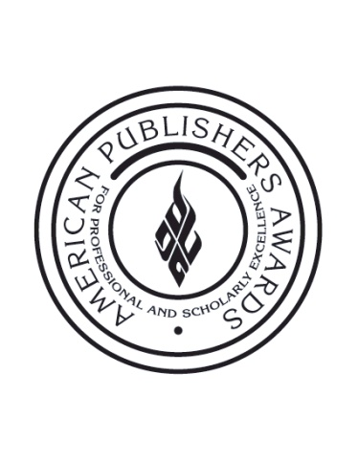

PROSE Awards to Present $10,000 Cash Prize
To Winner of 2013 R.R. Hawkins Award

New York, January 13, 2014 – The Professional and Scholarly Publishing (PSP) Division of the Association of American Publishers (AAP) announced today that it will be presenting a $10,000 cash prize to the winner of the 2013 R.R. Hawkins Award. The Hawkins Award is the top honor in the American Publishers Awards for Professional and Scholarly Excellence (PROSE). The winner will be announced on Thursday, February 6th at the PROSE Awards luncheon held during the PSP Annual Conference in Washington, DC.

This marks the first time since the inception of the Hawkins Award in 1976 that the winning author will receive a cash endowment. Also making history in 2013: for the sixth consecutive year the PROSE Awards received more entries than ever before.
“For almost 40 years, winning the R.R. Hawkins Award has marked the highest achievement in professional and scholarly publishing,” said PROSE Awards Chairman John A. Jenkins, President and Publisher Emeritus of CQ Press. "But this year’s ceremony will be truly memorable. It’s an honor to be able to recognize authors for the first time in this way. Equally significant, it’s an affirmation of the growing importance and influence of the PROSE Awards."
The R.R. Hawkins Award recognizes the best professional or scholarly works from across all disciplines of the humanities and sciences, and is given for the most outstanding book, reference work, journal or eproduct among the year’s award winners.
The PROSE Awards ceremony will be broadcast live from the Ritz Carlton Hotel in Washington, DC via www.proseawards.com.
About AAP
The Association of American Publishers is the national trade association of the U.S. book publishing industry. AAP’s more than 300 members include most of the major commercial publishers in the United States, as well as smaller and non-profit publishers, university presses and scholarly societies. AAP members publish hardcover and paperback books in every field, educational materials for the elementary, secondary, postsecondary, and professional markets, scholarly journals, computer software, and electronic products and services. The protection of intellectual property rights in all media, the defense of the freedom to read and the freedom to publish at home and abroad, and the promotion of reading and literacy are among the Association’s highest priorities. For more information on the PROSE Awards, please visit: www.proseawards.com. Follow award updates on Facebook and Twitter.

